**Changes in TBDR v1.4**

* Validation check for the ‘Remarks’ field during the upload process. Same remark will not get added for a given record after this validation.
* 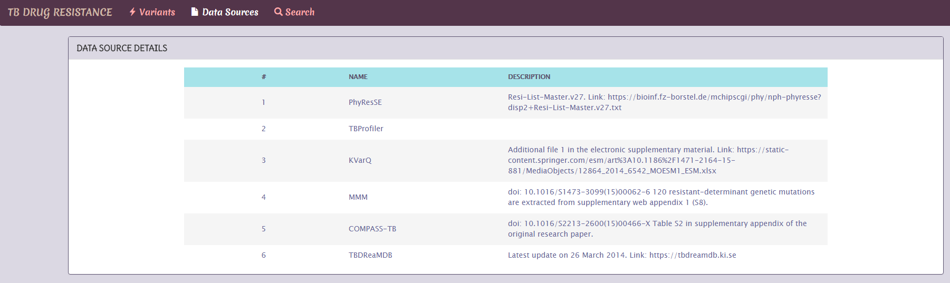Data source details are available for the public users.
* Modified width of the remark column.
* Added icons for the menu bar.
* Enter button is enabled for the Login process. After you have type-in the credentials you can press enter button instead of the button click.
* Added image for the web site title.